BIS 581 – Product Comments & Sentiment
Vamshi Krishna E
October 05, 2025

load libraries that you feel you need and explain why
- tidyverse: data wrangling & basic plotting.
- janitor: quick cleanup of column names (snake_case).
- tidytext: turn comments into words for frequency & sentiment.
- textdata: provides Afinn/Bing/NRC lexicons.
- RColorBrewer: for brewer.pal used in wordcloud
- wordcloud + RColorBrewer: colorful word cloud.
- igraph + ggraph: bigram (two-word) network diagram.
- knitr : neat tables in the knitted report.
- scales + forcats: nicer labels & factor ordering.
if (!("knitr" %in% installed.packages())) install.packages("knitr")
library(tidyverse)
library(janitor)
library(lubridate)
library(tidytext)
library(textdata)
library(RColorBrewer)
library(wordcloud)
library(igraph)
library(ggraph)
library(knitr)
library(scales)
library(forcats)

1) Load the .RDS
# The .Rmd and the .RDS should be in the same folder.
data_path <- "productsalescomments.RDS"
dat_raw <- readRDS(data_path)
dat <- dat_raw %>% clean_names()
glimpse(dat)
## Rows: 27,669
## Columns: 18
## $ transaction_id <int> 1, 2, 3, 4, 5, 6, 7, 8, 9, 10, 11, 12, 13, 14, 15,…
## $ time_key <chr> "2018-1", "2018-1", "2018-1", "2018-1", "2018-1", …
## $ year <int> 2018, 2018, 2018, 2018, 2018, 2018, 2018, 2018, 20…
## $ week <int> 1, 1, 1, 1, 1, 1, 1, 1, 1, 1, 1, 1, 1, 1, 1, 1, 1,…
## $ number_of_items <int> 4, 4, 4, 3, 1, 5, 3, 1, 5, 2, 3, 3, 4, 4, 5, 2, 1,…
## $ t_ounces <int> 24, 36, 36, 24, 4, 24, 16, 8, 32, 8, 20, 12, 24, 1…
## $ t_price <chr> "$21.00 ", "$23.50 ", "$22.50 ", "$17.00 ", "$3.75…
## $ t_cost <chr> "$8.02 ", "$11.71 ", "$11.65 ", "$7.86 ", "$1.35 "…
## $ customer_id <int> NA, NA, NA, NA, NA, NA, NA, NA, NA, NA, NA, NA, NA…
## $ star_rating <int> NA, NA, NA, NA, NA, NA, NA, NA, NA, NA, NA, NA, NA…
## $ comment <chr> "", "", "", "", "", "", "", "", "", "", "", "", ""…
## $ chocolate <int> 1, 1, 0, 0, 1, 1, 1, 0, 1, 1, 0, 0, 1, 1, 4, 0, 0,…
## $ feature <int> 2, 2, 3, 0, 0, 1, 1, 1, 3, 1, 2, 1, 1, 2, 1, 1, 1,…
## $ superman <int> 0, 0, 1, 0, 0, 1, 1, 0, 0, 0, 0, 0, 1, 0, 0, 1, 0,…
## $ vanilla <int> 1, 1, 0, 3, 0, 2, 0, 0, 1, 0, 1, 2, 1, 1, 0, 0, 0,…
## $ feature_flavor <chr> "Superman", "Superman", "Superman", "Superman", "S…
## $ parlor_location <chr> "Alpena", "Alpena", "Alpena", "Alpena", "Alpena", …
## $ production_location <chr> "Mount Pleasant", "Mount Pleasant", "Mount Pleasan…

Q2. Is any data prep needed? (Yes — minimal & safe)
Yes, - Trim extra spaces in text fields so repeated phrases match exactly.
- Create a transaction_id if one is missing, so each comment can be scored.
- Detect likely columns for customer id / parlor / production / comment / rating in case names vary slightly
norm_name <- function(x) tolower(gsub("[^a-z0-9]+","", x))
names_norm <- setNames(names(dat), sapply(names(dat), norm_name))
pick_col <- function(patterns) {
for (p in patterns) {
hit <- names(dat)[grepl(p, names(dat), ignore.case = TRUE)]
if (length(hit) > 0) return(hit[1])
}
return(NA_character_)
}
col_customer <- pick_col(c("^customer.*id$", "^cust.*id$", "^cid$", "customerid"))
col_parlor <- pick_col(c("^parlor.*loc", "^parlor$", "site.*parlor", "store", "location_parlor"))
col_production <- pick_col(c("^production.*loc", "^plant$", "^factory$", "prod.*site"))
col_comment <- pick_col(c("^comment$", "^comments$", "^review$", "feedback", "text"))
col_rating <- pick_col(c("^star.*rating$", "^rating$", "stars"))
knitr::kable(tibble(
role = c("CustomerID","ParlorLocation","ProductionLocation","Comment","Rating"),
column_detected = c(col_customer, col_parlor, col_production, col_comment, col_rating)
))
role | column_detected
CustomerID | customer_id
ParlorLocation | parlor_location
ProductionLocation | production_location
Comment | comment
Rating | star_rating

3) Minimal cleaning used throughout
- Trim spaces in text columns.
- Keep only non-empty comments for text analysis.
- Create a transaction id if none exists (for safe grouping).
# Make a generic transaction id if not present
if (!any(grepl("^trans", names(dat), ignore.case = TRUE))) {
dat <- dat %>% mutate(transaction_id = row_number())
} else {
tr_col <- names(dat)[grepl("^trans", names(dat), ignore.case = TRUE)][1]
dat <- dat %>% rename(transaction_id = all_of(tr_col))
}
# Basic trims
if (!is.na(col_comment)) {
dat <- dat %>% mutate(!!col_comment := str_squish(.data[[col_comment]]))
}
comments_df <- if (!is.na(col_comment)) {
dat %>%
filter(!is.na(.data[[col_comment]]), .data[[col_comment]] != "") %>%
transmute(
transaction_id,
customer_id = if (!is.na(col_customer)) .data[[col_customer]] else NA,
parlor = if (!is.na(col_parlor)) .data[[col_parlor]] else NA,
production = if (!is.na(col_production)) .data[[col_production]] else NA,
comment = .data[[col_comment]]
)
} else {
tibble(transaction_id = integer(), customer_id = character(),
parlor = character(), production = character(), comment = character())
}
knitr::kable(head(comments_df, 5))
transaction_id | customer_id | parlor | production | comment
5057 | 903 | Alpena | Mount Pleasant | If you like cherries this one’s for you
5058 | 959 | Alpena | Mount Pleasant | Ice cream is my love language
5059 | 5 | Alpena | Mount Pleasant | When life gives you lemons, make a lemon sorbet to go with your ice cream
5061 | 1123 | Alpena | Mount Pleasant | Superman you are flying high
5066 | 1375 | Alpena | Mount Pleasant | So good it’s bad. What an ice cream shop

Q3. Decide if you want to filter
Below is a simple filter switch. Set apply_filter <- TRUE and define a rule if you want to narrow scope (e.g., focus on one parlor). By default, no filter is applied to keep the analysis complete.
apply_filter <- FALSE # change to TRUE if you want to filter
parlor_to_keep <- NA # e.g., "Downtown"
if (apply_filter && !is.na(parlor_to_keep) && "parlor" %in% names(comments_df)) {
comments_df <- comments_df %>% filter(parlor == parlor_to_keep)
cat("Filter applied: only parlor =", parlor_to_keep, "\n")
} else {
cat("No filter applied (full dataset used).\n")
}
## No filter applied (full dataset used).

4) Top 15 meaningful words
Turn comments into single words (tokens), drop common stopwords, and show the most frequent 15 words.
if (nrow(comments_df) > 0) {
tidy_tokens <- comments_df %>%
unnest_tokens(word, comment) %>%
anti_join(stop_words, by = "word") %>%
filter(!str_detect(word, "^[0-9]+$"))
top15 <- tidy_tokens %>%
count(word, sort = TRUE) %>%
slice_head(n = 15)
knitr::kable(top15, col.names = c("Word", "Count"))
} else {
cat("No comments available to analyze.\n")
}
Word | Count
ice | 6408
cream | 6343
flavor | 1238
i’m | 994
cherry | 919
life | 867
scoop | 712
love | 607
time | 606
world | 531
eat | 497
dessert | 463
scream | 462
pie | 461
cone | 381

5) Word cloud
if (exists("tidy_tokens") && nrow(tidy_tokens) > 0) {
wc <- tidy_tokens %>% count(word, sort = TRUE)
suppressWarnings(wordcloud(
words = wc$word,
freq = wc$n,
max.words = 160,
random.order = FALSE,
scale = c(4, 0.8),
colors = brewer.pal(8, "Dark2")
))
} else {
cat("No tokens available for word cloud.\n")
}
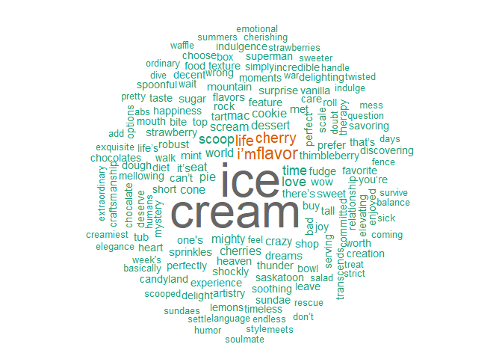

6) Top 5 customers by number of comments (+ Afinn sentiment)
Identified the five customers who post the most comments overall, and also compute their average Afinn sentiment (positive numbers = more positive words, negative = more negative).
if (!is.na(col_customer) && nrow(comments_df) > 0) {
# Afinn is integer-scored per word: negative to positive
afinn <- get_sentiments("afinn")
sent_scored <- comments_df %>%
mutate(comment_id = row_number()) %>%
unnest_tokens(word, comment) %>%
inner_join(afinn, by = "word") %>%
group_by(comment_id) %>%
summarise(comment_score = sum(value), .groups = "drop") %>%
right_join(comments_df %>% mutate(comment_id = row_number()),
by = "comment_id") %>%
mutate(comment_score = replace_na(comment_score, 0))
top5_customers <- sent_scored %>%
filter(!is.na(customer_id)) %>%
group_by(customer_id) %>%
summarise(
comments = n(),
avg_afinn = mean(comment_score),
total_afinn = sum(comment_score)
) %>%
arrange(desc(comments), desc(total_afinn)) %>%
slice_head(n = 5)
knitr::kable(
top5_customers %>% mutate(across(c(avg_afinn, total_afinn), round, 2))
)
} else {
cat("CustomerID column not found or no comments.\n")
}
## Warning: There was 1 warning in `mutate()`.
## ℹ In argument: `across(c(avg_afinn, total_afinn), round, 2)`.
## Caused by warning:
## ! The `...` argument of `across()` is deprecated as of dplyr 1.1.0.
## Supply arguments directly to `.fns` through an anonymous function instead.
##
## # Previously
## across(a:b, mean, na.rm = TRUE)
##
## # Now
## across(a:b, \(x) mean(x, na.rm = TRUE))
customer_id | comments | avg_afinn | total_afinn
99 | 38 | 1.45 | 55
180 | 38 | 1.29 | 49
251 | 38 | 1.21 | 46
474 | 37 | 1.49 | 55
662 | 37 | 1.41 | 52

7) Parlor site with the most comments – negative or positive?
count comments by parlor, then label each comment by Bing lexicon (positive/negative) and compute net scores.
if (!is.na(col_parlor) && nrow(comments_df) > 0) {
bing <- get_sentiments("bing")
comment_scores <- comments_df %>%
mutate(comment_id = row_number()) %>%
unnest_tokens(word, comment) %>%
anti_join(stop_words, by = "word") %>%
inner_join(bing, by = "word") %>%
mutate(score = ifelse(sentiment == "positive", 1, -1)) %>%
group_by(comment_id) %>%
summarise(sent_score = sum(score), .groups = "drop") %>%
right_join(comments_df %>% mutate(comment_id = row_number()), by = "comment_id") %>%
mutate(sent_score = replace_na(sent_score, 0))
by_parlor <- comment_scores %>%
group_by(parlor) %>%
summarise(
comments = n(),
net_sentiment = sum(sent_score),
avg_sentiment = mean(sent_score)
) %>%
arrange(desc(comments))
knitr::kable(by_parlor, digits = 2)
most_comments_parlor <- by_parlor %>% slice_max(order_by = comments, n = 1, with_ties = FALSE)
knitr::kable(most_comments_parlor, digits = 2, caption = "Parlor with the most comments")
} else {
cat("Parlor site column not found or no comments.\n")
}
Parlor with the most comments
parlor | comments | net_sentiment | avg_sentiment
Traverse City | 5467 | 1382 | 0.25

8) Production site with the most comments – negative or positive?
Same idea as the parlor analysis, grouped by production site.
if (!is.na(col_production) && nrow(comments_df) > 0) {
bing <- get_sentiments("bing")
comment_scores_prod <- comments_df %>%
mutate(comment_id = row_number()) %>%
unnest_tokens(word, comment) %>%
anti_join(stop_words, by = "word") %>%
inner_join(bing, by = "word") %>%
mutate(score = ifelse(sentiment == "positive", 1, -1)) %>%
group_by(comment_id) %>%
summarise(sent_score = sum(score), .groups = "drop") %>%
right_join(comments_df %>% mutate(comment_id = row_number()), by = "comment_id") %>%
mutate(sent_score = replace_na(sent_score, 0))
by_prod <- comment_scores_prod %>%
group_by(production) %>%
summarise(
comments = n(),
net_sentiment = sum(sent_score),
avg_sentiment = mean(sent_score)
) %>%
arrange(desc(comments))
knitr::kable(by_prod, digits = 2)
most_comments_prod <- by_prod %>% slice_max(order_by = comments, n = 1, with_ties = FALSE)
knitr::kable(most_comments_prod, digits = 2, caption = "Production site with the most comments")
} else {
cat("Production site column not found or no comments.\n")
}
Production site with the most comments
production | comments | net_sentiment | avg_sentiment
Mount Pleasant | 7952 | 2053 | 0.26

9) Top 10 most frequent full comments
Here count identical comment strings (after trimming), so you can see phrases that repeat.
if (nrow(comments_df) > 0) {
top_comments <- comments_df %>%
count(comment, sort = TRUE) %>%
slice_head(n = 10)
knitr::kable(
top_comments %>% rename(occurrences = n)
)
} else {
cat("No comments to count.\n")
}
comment | occurrences
Hello ice cream heaven - where have you been all my life | 263
If you like cherries this one’s for you | 246
This is crazy - whoever thought of this flavor | 244
Good | 233
Better than most | 232
What a shockly tart Robust Cherry Surprise flavor - you’ve got to love cherry for this one | 232
Wow. | 230
Perfect Strawberry Pie | 227
Really good ice cream | 226
So good it’s bad. What an ice cream shop | 226

10) Bigram network (comment word pairs)
Build a network of two-word sequences (bigrams) to show commonly paired terms. Remove stopwords and plot top connections.
if (nrow(comments_df) > 0) {
bigrams <- comments_df %>%
unnest_tokens(bigram, comment, token = "ngrams", n = 2) %>%
separate(bigram, c("w1","w2"), sep = " ") %>%
filter(!w1 %in% stop_words$word, !w2 %in% stop_words$word) %>%
count(w1, w2, sort = TRUE)
top_edges <- bigrams %>% slice_max(n, n = 120)
if (nrow(top_edges) > 0) {
g <- graph_from_data_frame(top_edges)
ggraph(g, layout = "fr") +
geom_edge_link(aes(width = n, color = n), alpha = 0.5) +
geom_node_point(color = "steelblue", size = 3) +
geom_node_text(aes(label = name), repel = TRUE, size = 3, color = "black") +
scale_color_gradient(low = "lightblue", high = "darkblue") +
labs(title = "Bigram Network (Top 120 Links)", x = NULL, y = NULL) +
theme_void()
} else cat("Not enough bigrams to draw a network.\n")
} else cat("No comments to build bigrams.\n")
## Warning: In `d`, `NA` elements were replaced with string "NA".
## Warning: The `trans` argument of `continuous_scale()` is deprecated as of ggplot2 3.5.0.
## ℹ Please use the `transform` argument instead.
## This warning is displayed once every 8 hours.
## Call `lifecycle::last_lifecycle_warnings()` to see where this warning was
## generated.
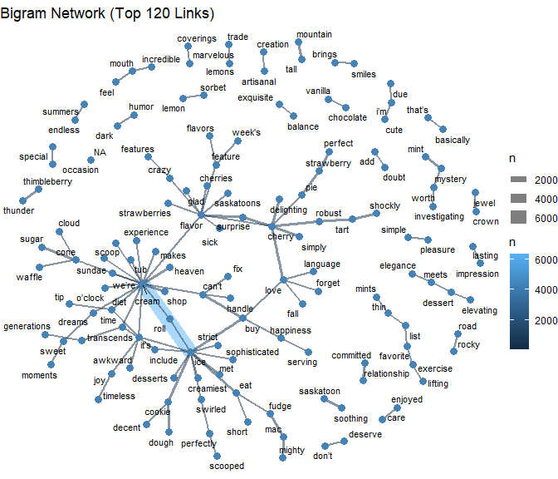

11) GRADS — Short recommendations based on feedback
## - If a specific parlor shows more negative average sentiment, review staffing and service speed during busy hours.
## - Repeating issues in top comments (e.g., 'melting', 'long wait') should map to operational fixes (cup/lid policy, queue management).
## - Consider re-running high-performing weekly feature flavors (by sales + positive sentiment) in off-peak periods.
## - Share positive recurring comments with marketing for social proof.

12) Appendix (optional quick checks)
# If you want to peek at which columns exist:
names(dat)
# Sample a few comments
comments_df %>% slice_sample(n = 10)

